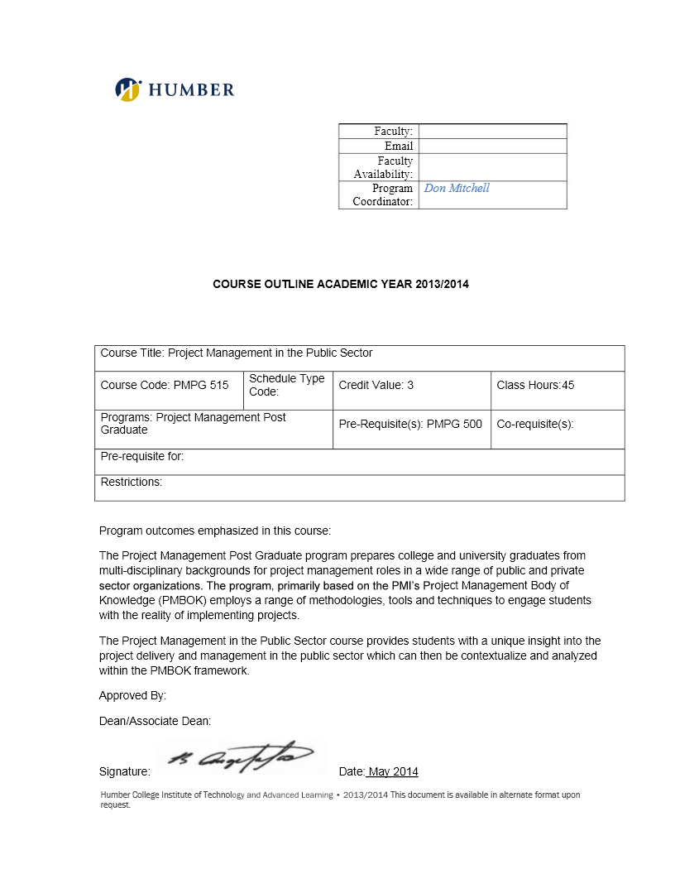

**BUS 5003 - Project Charter**

***Breaking Barriers in Housing***

***Document Version History***

|  |  |  |
| --- | --- | --- |
| Creation / Change Date | Author | Reason for Change |
|  |  |  |
|  |  |  |
|  |  |  |
|  |  |  |
|  |  |  |

|  |
| --- |
| Distribution List |
| 1. Ladan Asempour |
| 1. Alexandra Gladkova |
| 1. Kushwanth Sai Kolli |
| 1. Hao Lun Rong |
| 1. Christina Saju |

(All members contributed equally to all sections.)

**Table of Contents**

1.0 Project Overview 2

2.0 Project Objectives 2

3.0 Project Scope (Mandatory) 3

5.0 Project Preliminary Schedule (Mandatory) -

6.0 Project Cost (Mandatory) -

7.0 Project Organization (Mandatory) -

8.0 Project Risk Identification and Assessment (Mandatory) -

9.0 Acceptance Criteria (Mandatory) -

10.0 Appendix (Optional) -

# 1.0 Project Overview

1. Project Title: Breaking Barriers in Housing
2. Aim / purpose of the project
   * Problem the project will address / solve: This project aims to analyze how current rent regulations impact housing accessibility in regions with high unemployment. By evaluating requirements like proof of employment and acceptance of government or disability payments for rent, we will identify legislative and programmatic changes to make housing more inclusive and accessible. Our goal is to propose actionable policies that reduce barriers to stable housing, ultimately addressing homelessness in vulnerable communities.
   * Rationale for the proposed solution: We will study how current rental rules affect housing and identify where they create barriers. Then, we will recommend changes to make these rules fairer and more inclusive. This will help more people access stable housing and reduce homelessness.
3. Anticipated results (what will be different after the project has been completed), including a description of the value of this project to the public.

If the project succeeds, vulnerable groups in high-unemployment areas will face fewer housing barriers, homelessness will decrease, and policymakers will have data-driven solutions to improve accessibility.

# 2.0 Project Objectives

1. The overall goal of the project:

This project aims to identify and reduce housing accessibility barriers in high-unemployment regions by analyzing rent regulations, proposing policy changes, and engaging stakeholders to create more inclusive housing opportunities.

1. The list of objectives:
2. Analyze rent regulations in three high-unemployment regions by March 31, 2025, to identify specific barriers preventing vulnerable groups from accessing reliable housing.
3. Develop a report with three actionable policy recommendations by May 31, 2025, to provide stakeholders with solutions for improving housing accessibility.
4. Organize and conduct two stakeholder workshops by June 30, 2025, to gather feedback and ensure that proposed policies address diverse community needs.
5. Publish a public report summarizing findings and policy recommendations by July 31, 2025, to raise awareness and encourage broader discussions on housing accessibility challenges.
6. Assess the effectiveness of implemented policy recommendations and achieve a measurable 10% reduction in housing accessibility barriers in targeted regions by December 31, 2025.

# 3.0 Project Scope

This section provides a high level description of the scope of the project, and ***must*** include;

* In Scope work / items (product description, etc.)

| **Objective**  (must match wording from the previous section exactly) | **In Scope**  (sub-objectives / next level WBS) | **Out of Scope** | **Sequencing** (consecutive / concurrent) |
| --- | --- | --- | --- |
| 1. Analyze rent regulations in three high-unemployment regions by March 31, 2025, to identify specific barriers preventing vulnerable groups from accessing reliable housing. | 1. Identify important rent rules in selected regions 2. Identify challenges in accessing housing 3. Analyze how employment verification requirements affect people 4. Evaluate how government and disability payments are accepted | * Analysis outside the three selected regions. | * 1a. 1b. consecutive * 1c. 1d. concurrent |
| 1. Develop a report with three actionable policy recommendations by May 31, 2025, to provide stakeholders with solutions for improving housing accessibility. | 1. Conduct surveys and interviews with tenants, landlords, housing advocates, and policymakers. 2. Draft evidence-based proposals for policy changes that improve housing accessibility ensuring recommendations align with legal frameworks and implementation feasibility. 3. Prepare and distribute a professionally designed report across stakeholders summarizing findings and policy recommendations. 4. Collaborate with legal and housing experts to ensure that policy recommendations are actionable. | * Implementation of policy changes. | * All steps are consecutive |
| 1. Organize and conduct two stakeholder workshops by June 30, 2025, to gather feedback and ensure that proposed policies address diverse community needs. | 1. Present a list of proposed policy implementations, using infographics to illustrate the impact of each policy. 2. Conduct an open forum after the workshop, allowing for discussion of challenges and questions the stakeholders may have. 3. Issue a survey for feedback and improvement of the policies. 4. Implement feedback to update proposed policies. | * Ensuring consensus among stakeholders (mutual agreement on policy changes is not guaranteed). | * 3a. 3b. 3c   concurrent   * 3d.   consecutive |
| 1. Publish a public report summarizing findings and policy recommendations by July 31, 2025, to raise awareness and encourage broader discussions on housing accessibility challenges. | 1. Identify key audiences for the report and its distribution channels. 2. Draft and finalize the report with stakeholder feedback. 3. Publish the report on official platforms. 4. Track public engagement with the publication through clicks, mentions, downloads, comments and social media engagement. | * Tracking long-term social impact of the report. | * All steps are consecutive |
| 1. Assess the effectiveness of implemented policy recommendations and achieve a measurable 10% reduction in housing accessibility barriers in targeted regions by December 31, 2025. | 1. Collect data on the barriers before and after policy implementation to measure the impact of changes 2. Conduct surveys and interviews with policy users and stakeholders to gather qualitative feedback on the effectiveness 3. Analyze the data to identify trends and patterns that indicate a reduction in housing barriers 4. Develop a comprehensive assessment report that details the findings, methodologies used and recommendation for further improvements | * Providing financial aid, legal assistance or direct housing placement for tenants. | * 5a. 5d   consecutive   * 5b. 5c   concurrent |